Knowledge Check 3

Question 1

Which three fields are available when creating a Pie chart for visualization?

**Legend**

Group

**Details**

**Values**

Question 2

Consider the following chart:

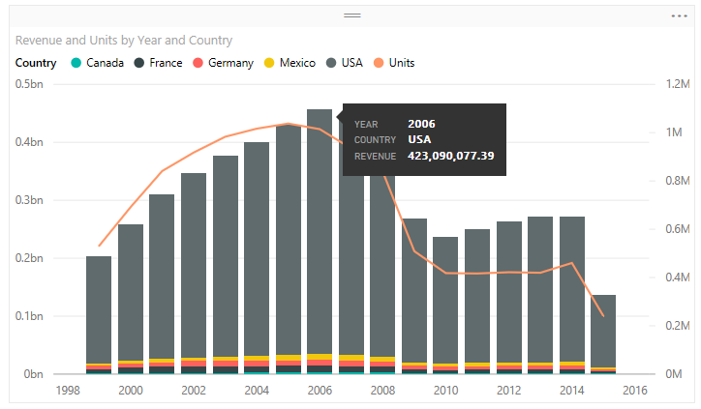

Drag and drop the fields to the corresponding settings to create the above chart.

|  |
| --- |
| Shared Axis |
| Year |
| Column Series |
| Country |
| Column Values |
| Revenue |
| Line Values |
| Units |

Question 3

By default, which level of filter behaves the same as a slicer in a report in Power BI Desktop

Visual level filter

**Page level filter**

 Report (All pages) level filter

Query level filter

Question 4

Consider the following chart:

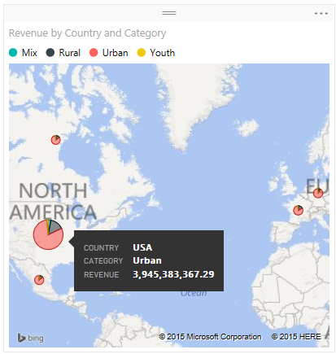

Drag and drop the fields to the corresponding settings to create the above chart.

|  |
| --- |
| Location |
| Country |
| Legend |
| Category |
| Longitude |
|  |
| Latitude |
|  |
| Size |
| Revenue |
| Tooltips |
|  |

Question 5

Consider the following chart:

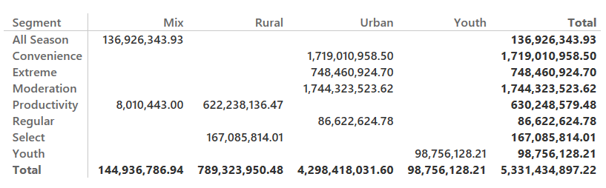

Drag and drop the fields to the corresponding settings to create the above chart.

|  |
| --- |
| Rows |
| Segment |
| Columns |
| Category |
| Values |
| Revenue |

Question 6

When creating a waterfall chart, which two field options that you need to define?

**Category**

**Values**

Y Axis

Size